Resize ec2 instance => Vertical Scaling

Resizing ec2 instances can be done only when the instance is stopped  
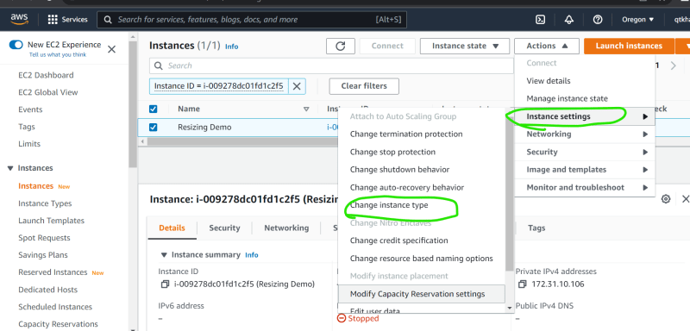  
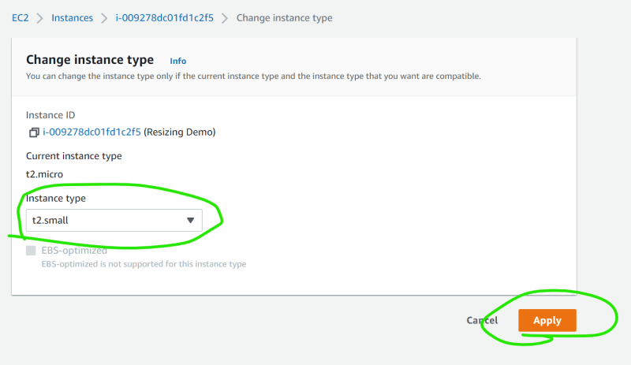  
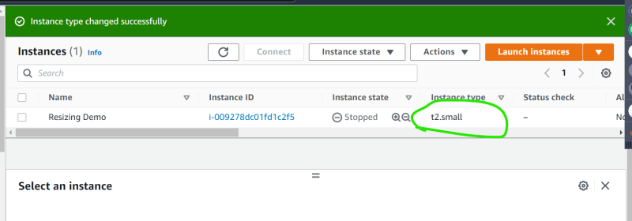

Vertical Scaling requires downtime.

Figure out what status checks are  
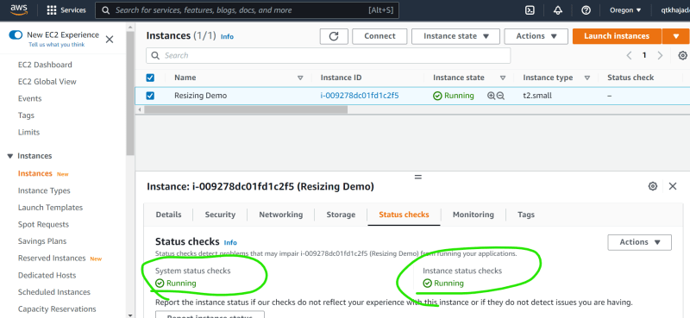

What does system status check failure mean?

Link: <https://docs.aws.amazon.com/AWSEC2/latest/UserGuide/monitoring-system-instance-status-check.html#types-of-instance-status-checks>